Pascal triangle:
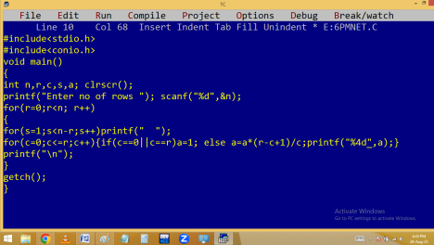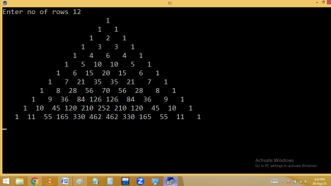
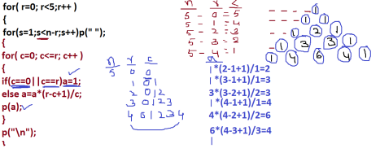break: It is a keyword is used within switch/loop to break. When break is occurred, the program execution jumped to the first statement after the switch / loop.
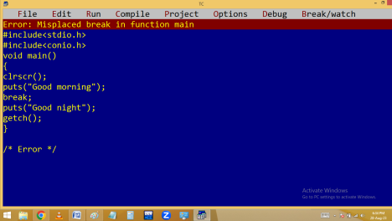
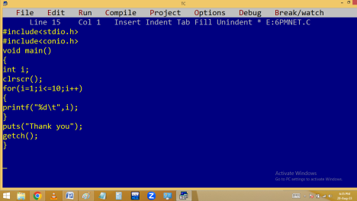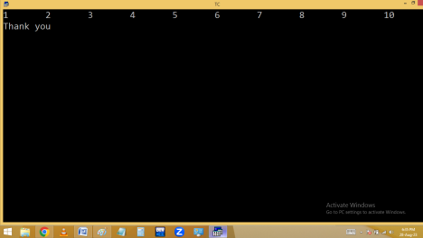
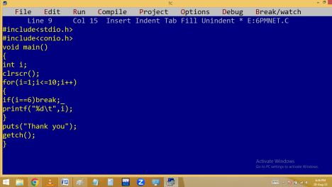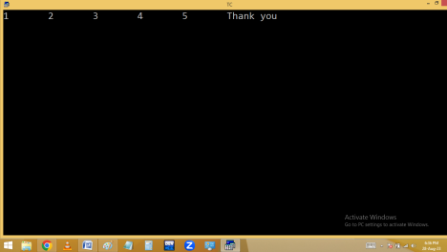
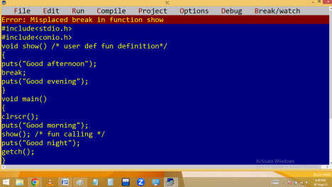
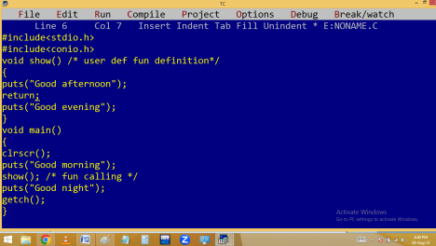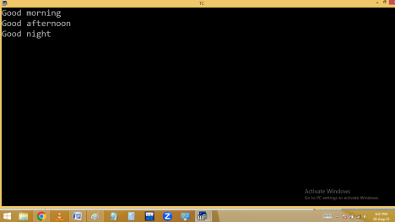
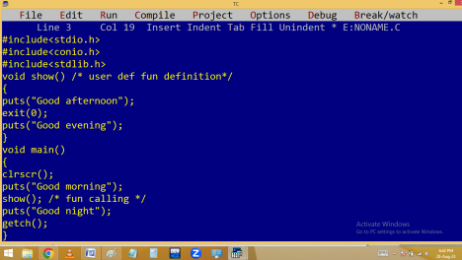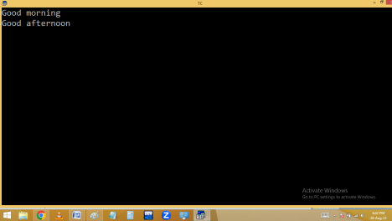
break | exit() | Return
Keyword | Function | Keyword
Header file not required | stdlib.h / process.h  required | Header file not required
Terminates switch / loop | Terminates total program | Closes that function only
Should be used within | Used any where | Used any where

switch/loop

continue: It is a keyword is used within loop to skip some of the iterations. When continue occurred, the program execution jumped to loop ending and later to beginning of the loop. Due to this the remaining statements in that loop are skipped.
Eg: printing 1..10 numbers except 3 and 7.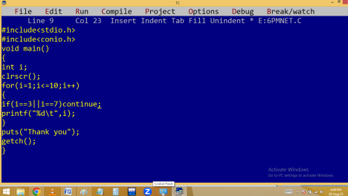
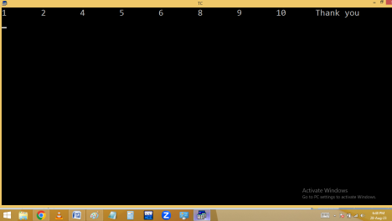Eg. write a program to print 1..n odd numbers using continue.
Even numbers:

